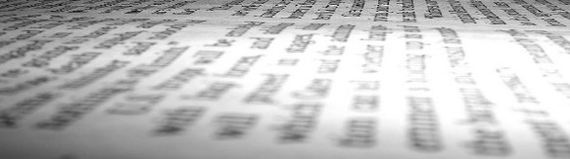

**Definitions**

Keepin’ It Real

**Tips & Strategies for Evaluating Fake News**

**Fake News:** Authentic material used in the wrong context or imposter news sites designed to look like brands we already know

**Click Bait:** Headlines that intentionally leave out crucial information to mislead user into clicking

**Bias:** A predisposition or tendency that distorts your ability to fairly weigh the evidence and prevents you from reaching a fair or accurate judgment

**Confirmation Bias:** Pursuing information that reassures or reflects a person’s particular point of view

**Verification**: an investigative process by which one gathers, assesses, confirms, and weighs evidence to search for truth

**http://libguides.lmu.edu/fakenews**

Adapted from:

Mandalios, J. (2013). RADAR: An approach for helping students evaluate Internet sources. *Journal Of Information Science*, 39, 470-478. doi:[10.1177/0165551513478889](http://journals.sagepub.com/doi/abs/10.1177/0165551513478889).

Meriam Library at California State University, Chico. (2010, September 17). *Evaluating information-Applying the CRAAP test.* Retrieved from <http://www.csuchico.edu/lins/handouts/eval_websites.pdf>

**FactCheck.Org (http://www.factcheck.org):** Founded in 2003, project of the Annenberg Public Policy Center of the University of Pennsylvania. The APPC was established by publisher and philanthropist Walter Annenberg

**Politifact (http://www.politifact.com/):** run by editors and reporters from the Tampa Bay Times, an independent newspaper in Florida

**Snopes (http://www.snopes.com/):** Created in 1995 by David Mikkelson, a California based writer. Site is a independent, self-sufficient entity funded through advertising revenues.

**Tin Eye** (<https://www.tineye.com)> or **reverse Google image search**: check if images have been photo-shopped, falsely reused, or changed to fit a story’s bias

**Resources**

**Use RADAR* to evaluate your latest news:**

ationale. Who is the audience? Is there bias expressed? Do they have evidence?

uthority. Who is this? What is their history and education?

ate. When was this story made available? Are there newer stories on the same topic?

ccuracy. Was this reviewed by experts? Are there citations or links to other stories?

elevance. Is this story addressing the topic? Does it add to your knowledge?

R

A

D

A

R

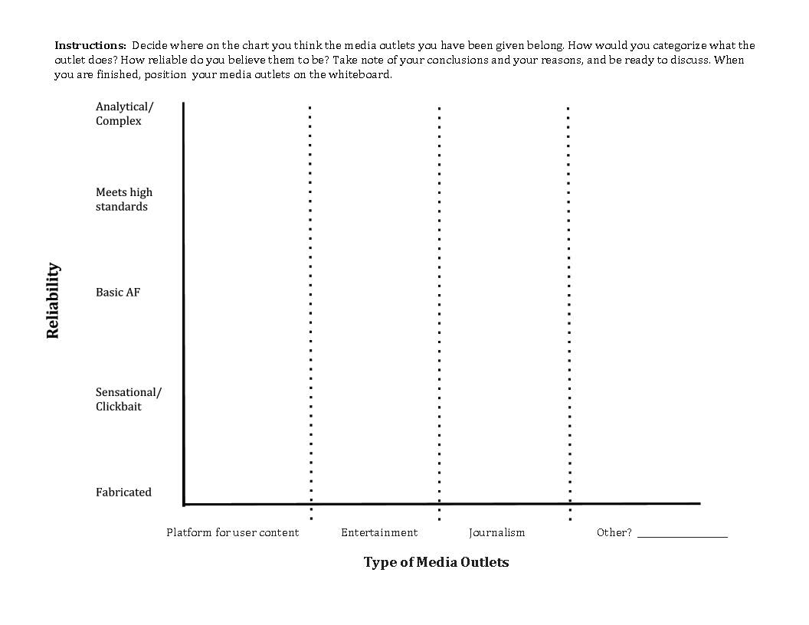

Basically

Reliable

How Reliable is Your Media?