TASK 2
Write 1 – 2 sentences or phrases for each part.

WGST 1100
FISHBOWL
ACTIVITY 2

Example Topics
- women of color and reproductive justice
- queer imagery in The Color Purple
- women’s suffrage and black women

Introduce the article. What is the point?

What was done in the article?
(Did they conduct a study? Did they write a literature review?)

Why is this a good article for your topic?

What isn’t included or mentioned in the article respect to your topic?

What are they saying overall? What is the takeaway?

Does this article support or argue against your topic?

Need some Help Skimming?

Parts of a Scholarly Article

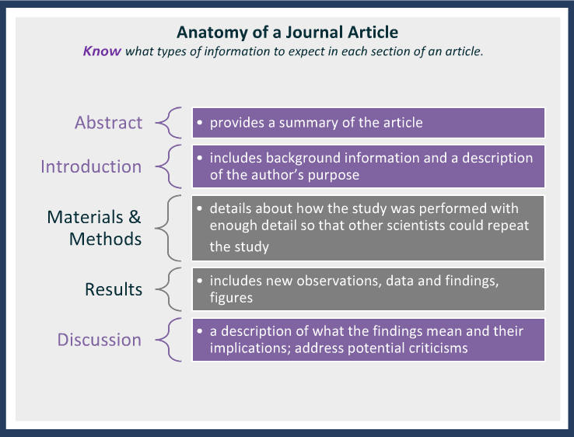
Turnbow, Dominique. BIMM 121 Library Workshop.Retrieved from http://libraries.ucsd.edu/bmcl/dturnbow/bimm121-library-tutorial/player.html.

