Misleading Visualization Activity Plan (Activity #1)

Link to google form: https://docs.google.com/forms/d/e/1FAIpQLSe67PHoY23BkiXgWwITxAciX4LeHnB_sBUTx5egCcx32Bdwfg/viewform?usp=sf_link

Format:
X# students per breakout room
- One group member shares screen and submits answers
- Use the google form to view each visualization and talk through each question

Additional resources to share with students:
- Data Visualization LibGuide: https://libguides.lmu.edu/digcitizen/dataviz
- Graphic of “5 Ways Writers Use Graphs to Mislead You”
- Junk Charts “Trifecta Checkup” for data viz criticism

Activity Images, Questions, and Answers
Each image is accompanied by the same two questions: How is the visualization misleading and how can the visualization be changed to better communicate the data

Image 1 – Average Female Height per Country
Source: https://badvisualisations.tumblr.com/
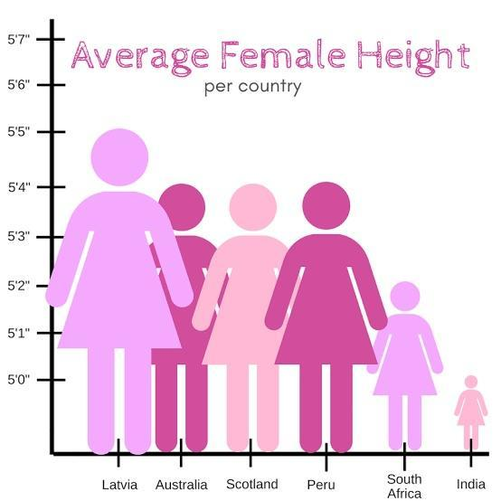
Question 1 – How is this visualization misleading?
- The y-axis doesn’t start at 0, which distorts the difference between the tallest country and shortest
- The distance between each inch is not consistent
- The colors might be hard to see visually
Question 2 – How can the visualization be changed to better communicate the data?
- Changing the y-axis (always start y axis at 0)
- Inconsistent spacing of y-axis
- One of the most common methods of distorting the message of visualizations is through manipulation of the y-axis!

Image 2 – Georgia County Covid Data, July
Source:
- original visualization: Georgia Department of Public Health daily status report (since removed)
- multiple news articles/blogs covering misrepresentation of data, including: https://www.ajc.com/news/state--regional-govt--politics/just-cuckoo-state-latest-data-mishap-causes-critics-cry-foul/182PpUvUX9XEF8vO11NVGO/?ct=t(Savvy_insights_0720)&mc_cid=d296d1136c&mc_eid=b03bc52df0
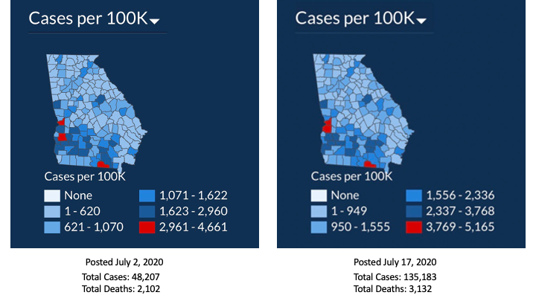
Question 5 – How is this visualization misleading?
- Scales are inconsistent, leading the array of COVID cases to appear less severe
- The scales are inconsistent between the two visuals
- Having only the top level of data be red is confusing since it is the only red section
Question 6 – How can the visualization be changed to better communicate the data?
- Making the scale consistent
- Keeping the scale consistent between visuals
- Using a single color gradient or using more than one gradient of red

Image 3 – Gun Deaths in Florida
Source: Reuters
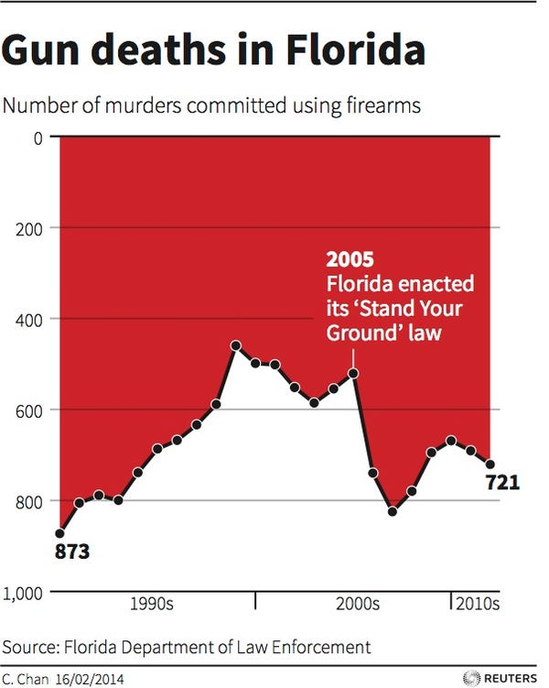
Question 8 – How is this visualization misleading?
- At first glance, the trend looks like it decreases following the law change
- Line graph was used, making the events look connected even though each event is distinct
Question 9 – How can the visualization be changed to better communicate the data?
- While visually impactful, the visualization goes against how people are trained to read graphs regarding the y-axis
- Note: this method can be done, but special attention needs to be placed on what component of the graph is pulling the eye – for instance, here the designer used a line graph which pulls our eye to naturally follows that path. If the designer used a bar graph, it could’ve been more effective: see the example of the better done

