“Four Moves and a Habit” in General Chemistry Lab Lesson Plan

Learning Objectives

- Students will practice with Mike Caulfield “Four moves and a habit” in order to learn that:
  - Before investing significant time in a document they should figure out more about the organization that produced it and
  - When looking at events or research they should look at what others say
  - And use the findings from these two questions to inform their analysis of the media artifacts we present them
- Students will understand the characteristics that differentiate scholarly and popular sources
- Upon completing this activity, students will
  - Identify strategies to evaluate scientific information or media on the web in an efficient manner
  - Understand the characteristics that differentiate scholarly versus popular literature

Instructor materials
- Outline
- Activity template in Google Docs (or another type of collaborative document)
- Handout or link to LibGuide that outlines the four moves (useful for student quick reference during class)
- Post class reflection survey (if needed)

Student Pre-Class Work
- Students will read some of Web Literacy for Student Fact-checkers:
  - Introduction: https://webliteracy.pressbooks.com/chapter/four-strategies/
  - Building a Fact Checking Habit by Checking your Emotions: https://webliteracy.pressbooks.com/chapter/building-a-habit-by-checking-your-emotions/
  - How to use Previous Work: https://webliteracy.pressbooks.com/chapter/how-to-use-previous-work/
  - Some Reputable Fact-Checking Organizations: https://webliteracy.pressbooks.com/chapter/fact-checking-sites/
  - Go Upstream to Find the Source: https://webliteracy.pressbooks.com/chapter/go-upstream-to-find-the-source/
  - Reading Laterally: https://webliteracy.pressbooks.com/chapter/what-reading-laterally-means/
  - Stupid Journal Tricks (Chapter 20) to How to Think About Research (Chapter 23)
    - https://webliteracy.pressbooks.com/chapter/stupid-journal-tricks/
    - https://webliteracy.pressbooks.com/chapter/finding-a-journals-impact-factor/
    - https://webliteracy.pressbooks.com/chapter/using-google-scholar-to-check-author-expertise/
    - https://webliteracy.pressbooks.com/chapter/how-to-think-about-research/
- Students will complete a pre-lab quiz based on the reading.
- Students will bring in an article related to a chemical with environmental or health effects they find on their social media networks or this tool: https://app.buzzsumo.com/research/content

Activity Outline (Approximately 75 minutes)

Introduction (5 minutes)
- Introduction of self and session
- Quick summary of the day: today’s class is to introduce you to a set of tools that you can use to evaluate information you find online. Specifically, about making a decision whether a website, blog post, tweet, or organization is worthy of your attention and further analysis.
  - Outline of class:
    - Introduction to four moves and introduce specific tactics
    - Practice in groups
    - At the end of class discussion of experience

Section 1: Overview of Four Moves and a Habit (20 minutes)
- Objective: review four moves & a habit and highlight tactics.
- Starting with a claim: high levels of the herbicide glyphosate and the corporation Monsanto, the EPA, and the FDA are actively silencing news of the high levels.
- Define the difference between a claim and a source
- Example: https://foodbabe.com/monsanto/
- There are four strategies and a habit:
  - Check for previous work
  - Go upstream to the source
  - Read laterally
  - Circle back
- Example of associated tactics (for quick reference):

Move | Associated Techniques
Look for previous work | - Scan for fact-checking sites or well-resourced papers  - Look for other coverage in Google News archive search.
Go upstream to the source | - Follow links to the source  - Use reverse image search to source a photo.  - Look for a scientific article if it’s cited (including how to identify a scholarly article)
Read Laterally | - Check Wikipedia background on organization  - If Wikipedia coverage doesn’t exist, check for google news coverage of the organization  - Scientific articles and impact factors

- Example links
  - https://foodbabe.com/monsanto/
  - https://www.snopes.com/fact-check/monsanto-suppressing-evidence-of-cancerous-herbicide-in-food/

Section 2: Practice Time (30 minutes)
- For the remainder of the work time, students will work in their lab pairs/groups.
  - Each lab pair will practice with at least one article.
  - Students log efforts in google doc (see screenshot of template below)
  - Note the fact checking resources in a Research Guide (if using)

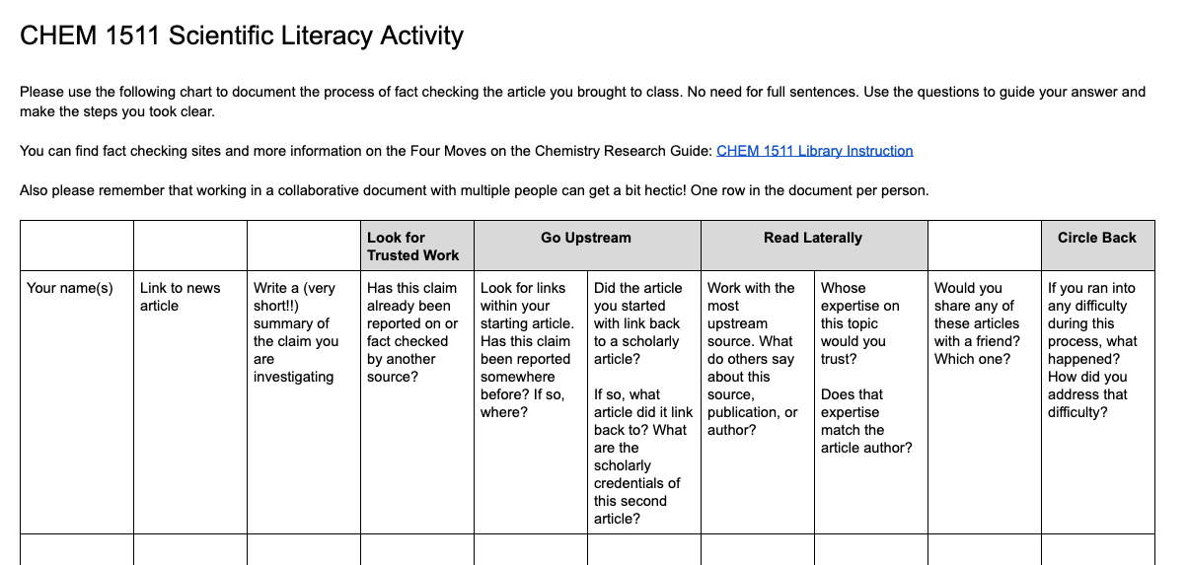

Section 3: Reflect and Review (15 minutes)
Objective: Have students share experiences and close the session
- Questions to ask
  - What was the most useful of the moves?
  - What was interesting? What did you not expect?
  - When might these skills come in handy?
- Emphasize the iterative nature of this process, and that it takes practice.
- Circulate reflection sheets, if using

Objectives are copied from the “Basic Pedagogical Principles” from the Class Sessions for Digipo, shared by Mike Caulfield. The lesson plans can be found in full at https://docs.google.com/document/d/1WqDcBVGWtbypGpbnqdmZXOolZQemANw0pRXRSOCvTPA/edit
Caulfield, Mike. Web Literacy for Student Fact-Checkers. Self-published, 2017. webliteracy.pressbooks.com, https://webliteracy.pressbooks.com/
Chart is modified from Mike Caulfield’ s DigiPo lesson plan: https://docs.google.com/document/d/1WqDcBVGWtbypGpbnqdmZXOolZQemANw0pRXRSOCvTPA/edit#heading=h.kteco9hbnlvt

