Library Warm-up Activity

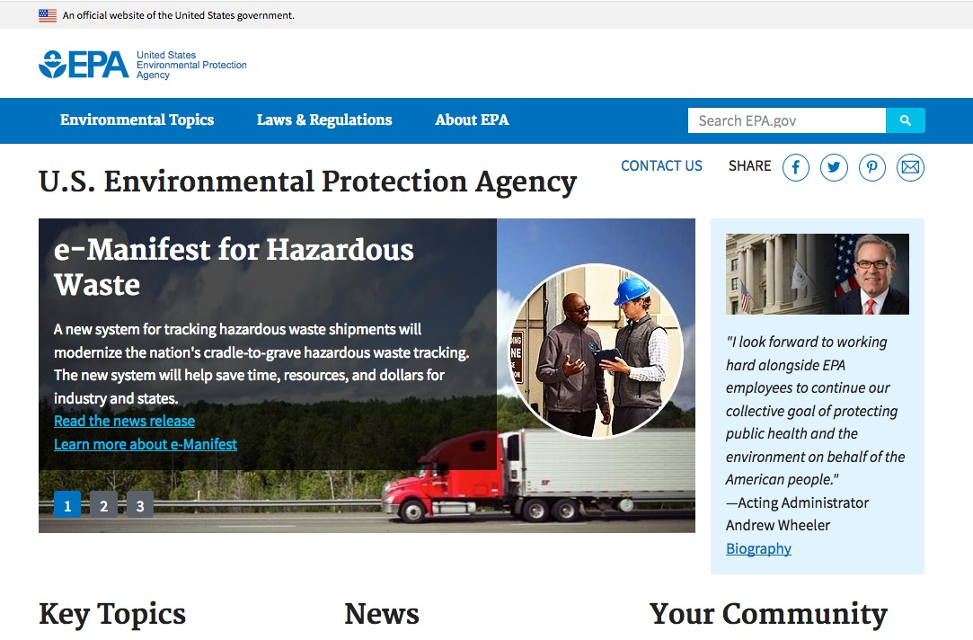
Go to the EPA website. Google it or go directly to https://www.epa.gov/

- How many times is “climate change” or “climate” mentioned on the homepage?

- Please read the light blue banner at the top of this page. Now click on January 19, 2017 Web snapshot or go to https://19january2017snapshot.epa.gov/

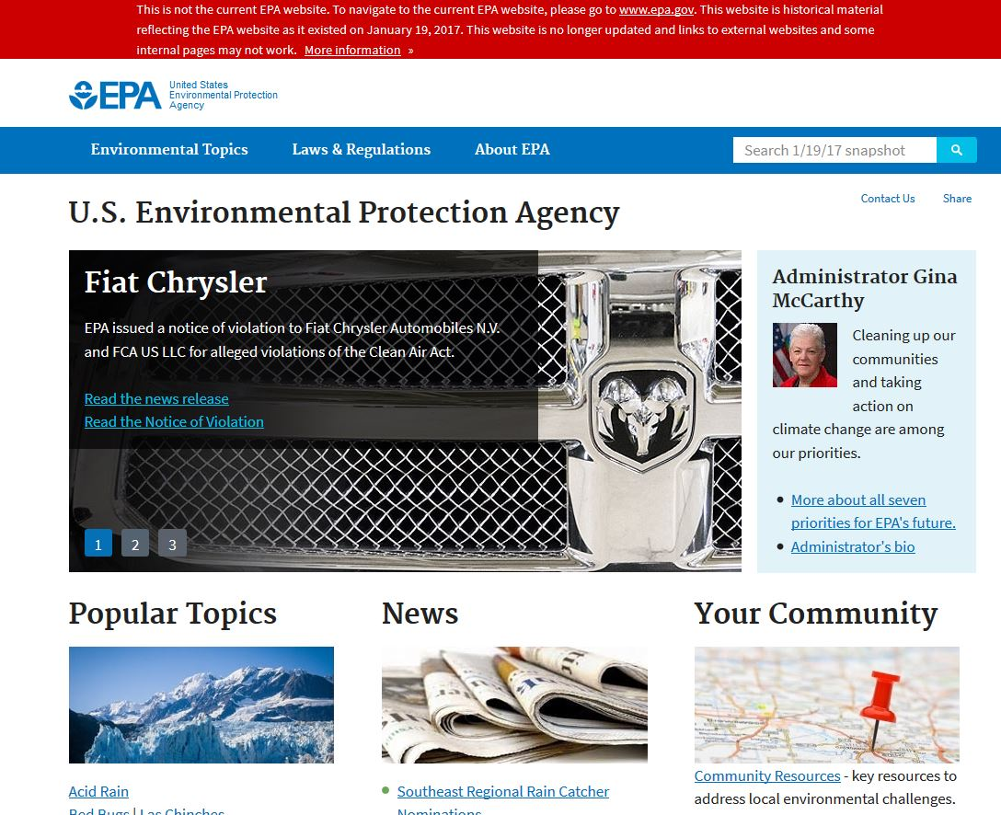
Please read the red banner at the top of this page.

- How many times is “climate change” or “climate” mentioned on the homepage?

In the blue navigation bar at the top, click on Environmental Topics. Then click on “Climate Change.”
- What is the address of the Climate Change page? https://________________________

- Now compare this to the current Climate Change page at www.epa.gov/climatechange What happened?

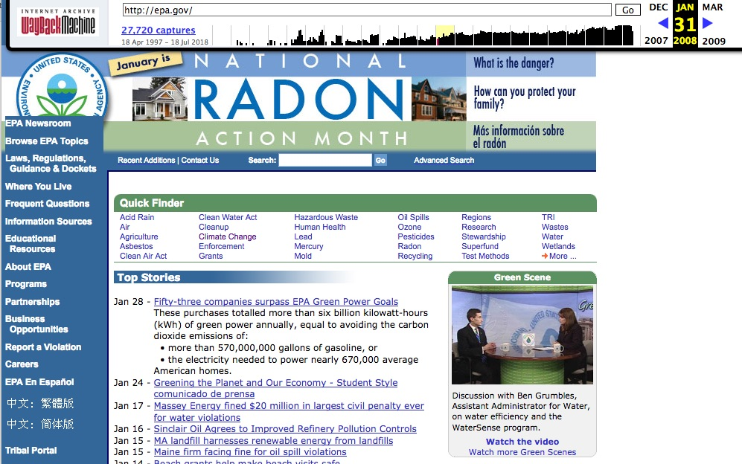
Go to the WayBack Machine at https://archive.org/web/
Type “EPA” in the search box and click on the first result.
You should now see a timeline. Click on 2008, then January 31.

- How many times is “climate change” or “climate” mentioned on the homepage?

Part 2

Please critically reflect on the new and older EPA websites. Discuss with your partner.

- What’s missing from the new EPA website?

  - How do you feel about that?

2. How does this impact our understanding of climate change?
  - How does this impact school children?

  - How does this impact voters and tax payers?

  - How does this impact scientists?

3. What social, economic, political, and power structures influence the production and dissemination of climate change information on the EPA website?

- Who benefits?

- Who is burden?

